This document includes:

- School Description
- Mission Statement
- Vision Statement
- Cultural Diversity and Maori Culture
- Curriculum
- Strategic Actions: 2022 - 2024
- 2022 Annual Plan
- 2022 Student Achievement Targets
- Board of Trustees Calendar

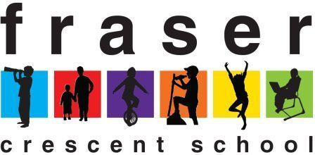

Fraser Crescent School Charter

Charter 2022

Connecting today’s children with tomorrow’s learning.

Introduction
Learning @ Fraser Crescent School

Fraser Crescent School is a learning community where we are Future Focussed, Respectful, Active Adventurers, who are Striving for Success, Enthusiastic and Resourceful.
Our vision is ‘Connecting Today's Children with Tomorrow's Learning’.

Our Fraser Curriculum has been developed to meet the diverse needs of our students now, and to support them in becoming confident, connected, actively involved learners for life.

Curriculum Principles are as follows:

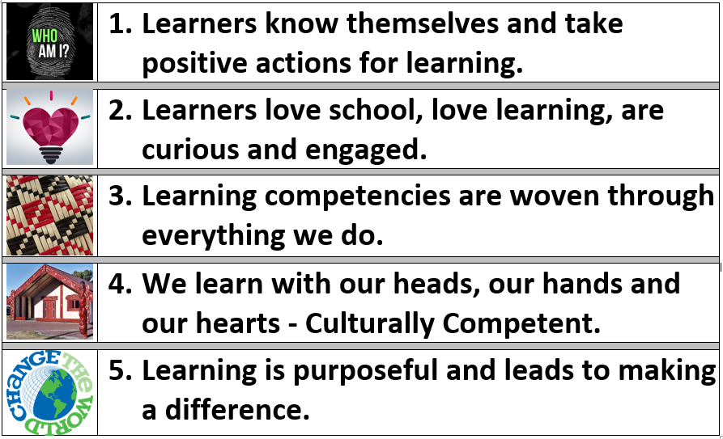

Our Values & Competencies
Curriculum Alignment of the Fraser Values, Key Competencies, 6 C’s, and Cultural Competencies.
Fraser Values | Key Competencies | Deep Learning Competencies - 6 C’s | Cultural Competencies
Future Focussed | Thinking | Critical Thinking & Creativity | Ako - Teaching & Learning
Respectful | Relating to others | Collaboration | Whanaungatanga - Relationships
Active Adventurer | Using language, symbols and texts | Communication | Wānanga - Communication
Striving for Success | Managing Self | Character | Manaakitanga - Ethic of care
Enthusiastic  Resourceful | Participating and Contributing | Citizenship | Tangata Whenuatanga - Place Based Learning

Description of Fraser Crescent School
Fraser Crescent School is centrally located in Redwood Street Upper Hutt, neighbouring Maidstone Intermediate. The school has an extensive playground area and a large playing field which backs on to Clyma Reserve and the Clyma Park Community Garden. The children at our school come from many areas within Upper Hutt, however the school has a community feel, helped by its smaller size. There are plenty of opportunities for parents, caregivers and whānau to get involved in the life of the school through the various groups which operate within the school.

The school is well resourced and has its own heated swimming pool, a school-wide computer network, bike track and large hall. The school is enormously proud of its sporting achievements, participating in a large number of local sporting fixtures, as well as providing a before school fitness club for the children. We also ensure that we have regular excursions into the wider community, utilising many local recreational facilities. This includes an annual 2 day Y4/5 school camp and a four day Year 6 school camp.

Fraser Crescent School ensures that its community is well informed of news and events occurring within the school. We have a fortnightly newsletter that goes home, as well as being emailed and published on the school website – www.frasercres.school.nz. We also communicate with our wider school community via Facebook (follow Fraser Crescent School). The school also provides substantial information to parents and caregivers about the achievement of their children. This includes regular reporting and communication with stakeholders.

The Fraser Values Explained
 | Future Focussed -Taking action today for a better tomorrow  This means empowering our students to make good decisions for their future. It is about teaching our students to set goals and work towards them. We want the children at Fraser Crescent School to realise that they have a voice and can create change in a rapidly transforming world.
 | Respectful - Being respectful to other people, places and beliefs  We aim to instil in our students the value of respect. This starts by respecting ourselves, which leads to students gaining increased confidence and self-esteem. We also encourage our students to be respectful of others, their ideas and beliefs.
 | Active Adventurer - Get involved, give it a go and wonder!  At Fraser Crescent School being active in both mind and body is very important. We implement a range of programmes and sports aimed at increasing students’ physical abilities and fostering a love of the outdoors. Our teachers aim to develop curiosity among our students to become excited inquirers about their learning.
 | Striving for Success - Not the best, but trying your best  Our Striving for Success value is about empowering our children to try their best. We aim to develop perseverance and resilience within our students, as well as equipping them with the necessary skills and tools to effectively problem solve.
 | Enthusiastic - Be involved and make learning fun  For students to really connect with their learning, it needs to be fun and engaging. This starts with an Enthusiastic Board of Trustees and permeates through the school, the notion of being involved, positive and having a can-do attitude.
 | Resourceful - Knowing about and using resources in our learning  In an ever changing world, our children need to think outside the square and be highly resourceful. At the heart of our Resourceful value, is the ability for our students to self-select the most appropriate tools for any challenge. We also want our children to be aware of their impact on the environment and global pressure on some of our natural resources.


PB4L School-Wide – Positive Behaviour for Learning

Fraser Crescent School engaged with the Ministry of Education in 2019 to begin the 3 - 5 year journey. Positive Behaviour for Learning to improve address problem behaviour, improve children’s well-being, and increase student achievement. Through this initiative we will create a school culture that built on positive and respectful relationships. As a school we want to create a positive and supportive, fun environment for our students and staff, where we encourage our students to make positive behaviour choices and to engage in exciting learning opportunities.

Our Purpose:
At Fraser Crescent School, we believe that a positive school culture, consistent approach to teaching and learning and an engaging curriculum will positively impact on our Ako and Well-Being.

NPDL – New Pedagogies for Deep Learning
Our Vision: To develop leadership capacity within our staff to lead deep change, to create a collaborative culture of learning and to embrace real world learning that connects and challenges our students and provides them with multiple opportunities for learning and multiple perspectives.

At Fraser Crescent School we are embracing the new pedagogies for deep learning through the four lenses of Learning Partnerships, Learning Environments, Pedagogical Practices and Leveraging Digital. Deep Learning is the ability to master existing knowledge, use this existing knowledge and make connections to new learning to create new meaning. It is facilitated through questioning and authentic engagement in meaningful real world challenges.

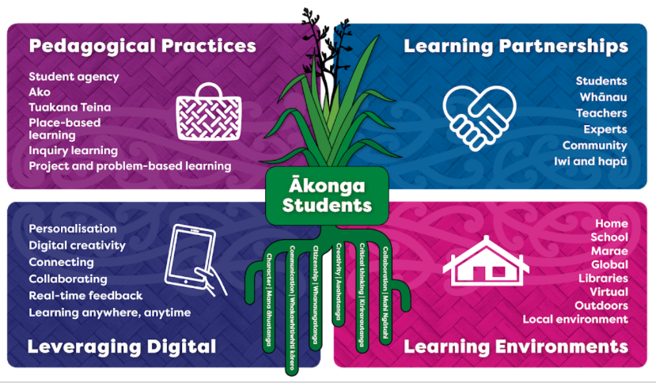
When we help young people make connections between what they are learning and the real world, they learn that everything is connected and that learning is a continuous process. Learning from experience is one of the best ways to give akonga the skills they need for living, working, and learning in the modern world. Deep learning provides experiences that nurture competencies (i.e. 6 Cs, Key Competencies, Cultural Competencies) and effective learning partnerships. This type of learning supports the values of our school, helping akonga thrive and become confident, connected, actively involved lifelong learners.

Learner agency is about students having the understanding, ability, and opportunity to be part of learning design and taking action to intervene in the learning process and become effective lifelong learners.

“Learning contexts should encompass conversations that are challenging, problematic, engaging and horizon stretching. The teacher's tasks is to create possibilities and opportunities for students to become, learn, and act.” (Dewey, 1916)

Cultural Diversity and Maori Dimension

How will our school reflect New Zealand’s Cultural Diversity
The children at Fraser Crescent School represent many different nationalities. Current ethnicities of our students include 3% Pasifika, 4% African/South African, 6% Asian, 37% Māori, 47% New Zealand European, as well as students from a range of other nations. Through our inquiry learning topics and our delivery of the Social Studies strands relating to Identity, Culture and Organisation, students will have the opportunity to learn about themselves and their culture and heritage, and the culture and heritage of other students.

These programmes will recognise the multicultural society in which we now live, as well as increasing awareness and respect for cultures and beliefs that differ from our own.

How will our school reflect the unique position of Maori?
There are a significant number of Maori children at Fraser Crescent School and it is essential that this is reflected in the life of the school. The school participates in regular visits to Orongomai Marae which has strong links with many of our Maori Whanau at school. The school also has a Whanau Liaison role which is aimed at supporting families in a range of areas.

What reasonable steps will the school take to incorporate tikanga Maori (Maori culture and protocol) and Te Reo (Maori Language) into the school curriculum?
Tikanga Maori is incorporated into the school’s Marae study, Whakatauki, waiata and Kapa Haka programmes. Further assistance is being sought to increase teachers’ awareness of customs and protocols. Te reo Maori and tikanga Maori will be integrated into curriculum areas in an appropriate manner. The Maori language, te reo Maori, will be part of the school’s curriculum.

What will the school do to provide instruction in Te Reo Maori (Maori language) for full time students whose parents request it?
If a parent were to make such a request, the matter would be referred to the Board of Trustees for consideration. Presently there are teaching staff within the school who could run an immersion programme, however all our classrooms are currently mainstream, so significant restructuring within the school would need to occur to meet such a request, including personnel, budgets and resources. If required, assistance may be provided to find another school appropriately equipped to provide such a programme, whilst Fraser Crescent School is not in a position to adequately establish an immersion programme.

What will the school do to discover the views and concerns of the school’s Maori community?
We find that with almost all consultation, a personal approach is much more effective. We also aim to ensure that responses to any consultation are reflective of our school cultural demographic. We also encourage parents and caregivers to bring children to meetings and consult with the community regarding the most convenient meeting times and locations. As part of reporting to the Board of Trustees on student achievement, the Principal will report separately on Maori achievement where appropriate.

Board of Trustees
The Fraser Crescent School Board of Trustees recognises the importance of training for members of the School Board. In an effort to improve the performance of the Board, both professional development and external support will be utilised when appropriate. As part of the Board meetings, members of the Board will be asked regularly to reflect on their conduct as a Board member, as well as the way in which Board meetings are held. The performance of the Board will also be monitored through the use of the Self Review Tools for Boards. The Board of Trustees performance is also linked to the school’s annual student achievement targets. The Board has created an environment where members constantly consider how they can impact on the achievement of the students. This may be in terms of providing resources, asking the right questions and ensuring that school targets Strive for Success.

Equal Opportunities Employer
Fraser Crescent School Board of Trustees is an Equal Opportunities Employer. Our Equal Employment Opportunities policy can be viewed online at http://frasercres.schooldocs.co.nz/. The Equal Opportunities policy ensures that all employees and applicants for employment are treated according to their skills, qualifications, abilities and aptitudes, without bias or discrimination.

.

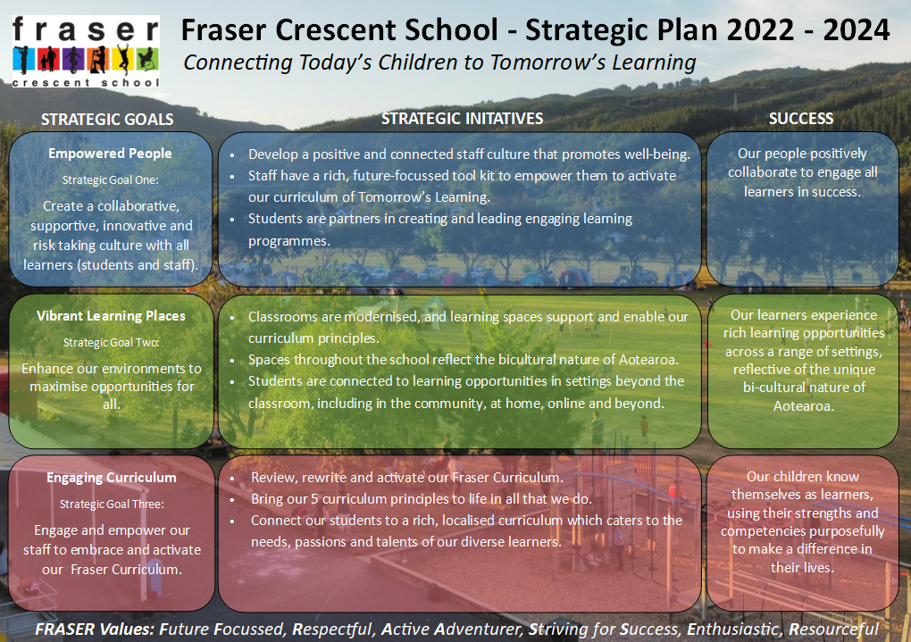
3 Year Strategic Roadmap
 | 2022 |  |  |  | 2023 |  |  |  | 2024
Goals | T1 | T2 | T3 | T4 | T1 | T2 | T3 | T4 | T1 | T2 | T3 | T4 | Success
Strategic Goal 1:  Create a collaborative, supportive, innovative and risk taking culture with all learners (students and staff). | Develop a positive and connected staff culture that promotes well-being. |  |  |  |  |  | Staff culture check in |  |  |  | Staff culture check in |  | Our people positively collaborate to engage all learners in success.
 | Staff have a rich, future-focussed tool kit to empower them to activate our curriculum of Tomorrow’s learning.  NPDL Focus |  |  |  | Staff have a rich, future-focussed tool kit to empower them to activate our curriculum of Tomorrow’s Learning.
 |  |  |  |  |  | Students are partners in creating and leading engaging learning programmes.
Strategic Goal 2:  Enhance our environments to maximise opportunities for all. | Classroom modernisation project |  |  |  |  |  | Learning spaces support and enable our curriculum principles. |  |  |  |  |  | Our learners experience rich learning opportunities across a range of settings, reflective of the unique bi-cultural nature of Aotearoa.
 |  |  |  |  |  |  |  |  | Spaces throughout the school reflect the bicultural nature of Aotearoa.
 |  |  |  |  |  |  |  |  |  | Students are connected to learning opportunities in settings beyond the classroom, including in the community, at home, online and beyond.
Strategic Goal 3:  Engage and empower our staff to embrace and activate our Fraser Curriculum. |  | Review, rewrite and activate our Fraser Curriculum. |  |  |  |  |  |  |  |  |  |  | Our children know themselves as learners, using their strengths and competencies purposefully to make a difference in their lives.
 |  |  | Bring our 5 curriculum principles to life in all that we do.
 |  |  |  |  |  |  |  |  | Connect our students to a rich, localised curriculum which caters to the needs, passions and talents of our diverse learners.

ANNUAL PLAN: GOAL ONE  Create a collaborative, supportive, innovative and risk taking culture with all learners (students and staff). |  | Initiative 1: Develop a positive and connected staff culture that promotes well-being
Outcome: Our people positively collaborate to engage all learners. | Measures:  - Staff Culture Review – Chris Rowan July 2021 (follow up review in April 2022)  - NZCER Teacher Workplace Survey September 2021
Key Actions | Accountable |  | Responsible | Resources | Complete by
Share initiatives and plans for 2022 at January Teacher Only Days. Revisit this throughout the year. | John Channer |  | Teaching Team | Time at Teacher Only Day  Staff Meeting revisits | Start of school year  Regular revisits
Establish ways of working guidelines. Emails, messenger, meetings (Jan TOD) | John Channer |  | Teaching Team | Time at Teacher Only Day | Start of school year
Consolidate Pop-in teacher observations, ensuring these are occurring once a term. | Holly King, Benzi Rodrigues |  | Teaching Team | Leadership release and CRT time | End of Term 1 2022
Run staff meetings and implement actions based on key findings from NZCER Teacher Workplace Survey. This includes involvement in decision making, school expectations, consolidating initiatives, professional learning and leadership opportunities and feedback. | John Channer |  | Teaching Team | Staff Meeting Time | End of Term 2 2022
Re-engaged with Chris Rowan to follow up on 2021 Culture review. | John Channer |  | Chris Rowan and Teaching Team | $3000 | End of Term 1 2022  5th April Staff Meeting
Establish regular Puzzle of Practice meetings | Holly and Benzi |  | Teaching Team | Staff Meeting time | End of Term 1 2022
Complete NZCER Teacher Workplace Survey and compare with 2021 results | John Channer |  | Teaching Team | $500 | End of Term 3 2022

ANNUAL PLAN: GOAL ONE  Create a collaborative, supportive, innovative and risk taking culture with all learners (students and staff). |  | Initiative 2: Staff have a rich, future-focussed tool kit to empower them to activate our curriculum of Tomorrow’s Learning.
Outcome: Our people positively collaborate to engage all learners. | Measures:  - Mathematics achievement data  - Teacher reflection EOY information and Curriculum Checklist information.  - NPDL School Conditions Rubrics, planning scans  - PB4L Pastoral Data Tracking. Sense Maker stories analysis.
Key Actions | Accountable |  | Responsible | Resources | Complete by
Update Fraser token system to a more sustainable option in line with our school’s Resourceful value. (PB4L) | John Channer |  | Teaching Team | $3000 | End of Term 1 2022
Participate in PB4L tier 2 training. Share new learning, upskill staff throughout the year. | Holly King, Zoe Draper |  | Teaching Team | Staff Meeting time  Release costs for PB4L Training | End of Term 4 2022
Review existing and develop new PB4L Lesson Plans | Holly King |  | Teaching Team |  | Ongoing throughout the year
Undertake analysis of Pastoral Data throughout the year. Share data with staff, Board of Trustees. (PB4L) | Holly King |  | Teaching Team |  | Ongoing throughout the year
Begin Mathematics PLD programme with facilitator (Julie Roberts). More details to come if PLD application is successful. | Holly King |  | Julie Roberts  Teaching Team | MOE Funded PLD  Teacher release days  Staff Meeting time | Ongoing throughout the year
Complete NPDL Project PLD  - Embed the deep learning goals within our school vision and values  - Pedagogy of Deep Learning will be embraced and become the foundation of our school Deep Learning/Inquiry programme.  - Ensure our school and staff embrace and provide a collaborative learning environment for all.  - Ensure that all learners take agency in their learning and are encouraged to reflect on their learning and experience real world learning opportunities.  - Partake in NPDL PLD with the UHEN to support NPDL Lead Teacher and staff. | John Channer |  | Teaching Team | Time at Teacher Only Day  Staff Meeting Revisits  Professional Development, CORE Education  (Margot McKeegan)  Costs $3000 TBC | End of Term 1 2022  Ongoing throughout the year

ANNUAL PLAN: GOAL TWO  Enhance our environments to maximise opportunities for all. |  | Initiative 1: Classrooms are modernised, and learning spaces support and enable our curriculum principles.
Outcome: Our learners experience rich learning opportunities across a range of settings, reflective of the unique bi-cultural nature of Aotearoa. | Measures:  - Final sign-off and all code of compliance documentation complete
Key Actions | Accountable |  | Responsible | Resources | Complete by
Be actively involved in the management of the classroom upgrade and related building work. | John Channer |  | Mark, Scott, Warren, Anna Windsor | $1,430,000.00  Capital Works | July 2022
Staffroom remodel project is completed. | John Channer |  | Mark Scrimshaw | $63,599.00 (SIP) | April 2022
Learning Support Coordinator space is completed. | John Channer |  | Mark Scrimshaw | $65,000.00 | April 2022

ANNUAL PLAN: GOAL THREE  Engage and empower our staff to embrace and activate our Fraser Curriculum. |  | Initiative 1: Review, rewrite and activate our Fraser Curriculum.
Outcome: Our children know themselves as learners, using their strengths and competencies purposefully to make a difference in their lives. | Measures:  - A completed and comprehensive Fraser Curriculum.  - Detailed guidance is provided in all key aspects of our local Fraser Curriculum  - Logical and incremental pathways for key programmes are developed
Key Actions | Accountable |  | Responsible | Resources | Complete by
Compile all current curriculum components into a single document. | John Channer |  | Curriculum Team | Release Days x2 | End of Term 2 2022
Identify areas within the curriculum which require reviewing. | John Channer |  | Curriculum Team | Release Days x2  Staff Meeting Time | End of Term 2 2022
Rewrite all identified areas of the curriculum document. | John Channer |  | Curriculum Team and Teaching Team | Release Days x4  Staff Meeting Time | End of Term 3 2022
Check for pathways through various key programmes. | John Channer |  | Teaching Team | Staff Meeting Time | End of Term 4 2022

ANNUAL PLAN: GOAL THREE  Engage and empower our staff to embrace and activate our Fraser Curriculum. |  | Initiative 2: Bring our 5 curriculum principles to life in all that we do.
Outcome: Our children know themselves as learners, using their strengths and competencies purposefully to make a difference in their lives. | Measures:  - Previous Me and My School Data  - Teachers Curriculum Self Reflection document (2019)  - Fraser Curriculum Student Reflection (2019)  - New baseline data to be gathered.
Key Actions | Accountable |  | Responsible | Resources | Complete by
Gather baseline data on the following:  - Percentage of children who are able articulate their own learning goals and are taking actions to achieve these.  - Children’s attitude to school. Me and My School questions ‘I enjoy learning at school’ and ‘I often feel bored at school’.  - Unit and lesson planning scans for cultural competency/opportunities, Deep Learning 6C’s and the outcomes and differences of units.  - Other information pertaining to our Curriculum Principles. | John Channer |  | Principle Review team | Release days x4 | End of Term 3 2022
Complete and review the Curriculum 1 Page documents | John Channer |  | Teaching Team | Staff Meeting Time | End of Term 4

Fraser Crescent School 2022 Student Achievement Targets

Goal One: 60% of competency goals will be achieved to level green.

Goal Two: 90% of students will meet their goal on the Engagement, Equity and Attendance Register

Goal Three: Mathematics – See tables below for targeted shifts in mathematic achievement for selected students in Years 4 and 5.

Year 4 Mathematics Targets

 | At 1 | Early 2 | At 2
End of 2021 Results | 12 | 16 | 1
2022 End of Year Targets |  | 9 | 14

Year 5 Mathematics Targets

 | At 1 | Early 2 | At 2 | Early 3 | At 3
End of 2021 Results | 6 | 8 | 8 | 1 | 1
2022 End of Year Targets | 2 | 6 | 12 | 9 | 8

Board of Trustees Calendar
Fraser Crescent School - Board of Trustees - Self Review - 3 Year Calendar (March 2022 Version)
Year and Meeting | 2022  Operating Funding: Instalment (1 January) | 2023  Operating Funding: Instalment (1 January) | 2024  Operating Funding: Instalment (1 January)
Term 1  Meeting 1  Meeting 2 | Appointment of BOT Chairperson  Charter 2022-2024, Targets  SchoolDocs Review  Health and Safety Management  Safety Management System  Risk Management  Health and Safety Induction  Visitors  Emergency, Disaster, and Crisis Management  Emergency Planning and Procedures  School Closure  Emergency Management  Disaster Management  Crisis Management  COVID-19 Information | Appointment of BOT Chairperson  Charter 2023-2025, Targets  SchoolDocs Review  Legislation and Administration Policy  Student Attendance  Enrolment  Privacy  Records Retention  Copyright  Creative Commons (optional)  Uniform/Dress (optional)  BAS and Governance Manual | Appointment of BOT Chairperson  Charter 2024-2026, Targets  SchoolDocs Review  Te Tiriti o Waitangi  Governance and Management  Board Responsibility  Principal Responsibility  Documentation and Self Review Policy  School Planning and Reporting  Recognising Student Achievement  Reporting to Parents on Student Progress and Achievement  Parents and Whānau
Term 1  Meeting 1  Meeting 2 | March Roll Return  Principal Performance Agreement  Analysis of Variance | March Roll Return  Principal Performance Agreement  Analysis of Variance | March Roll Return  Principal Performance Agreement  Analysis of Variance
Term 2  Meeting 1  Term 2  Meeting 2 | Annual Report sent to MOE 31st May  Annual Report (2021)  Operating Funding: Instalment 2  SchoolDocs Review  Healthcare  First Aid  Medicines  Accidents and Injuries  Health Conditions and Illness  Infectious Diseases | Annual Report sent to MOE 31st May  Annual Report (2022)  Operating Funding: Instalment 2  SchoolDocs Review  Education Outside the Classroom  EOTC Safety Management  EOTC Planning and Review  EOTC Risk Management  EOTC Roles and Responsibilities  EOTC External Providers  EOTC Staff Competence  EOTC Process  EOTC Forms | Annual Report sent to MOE 31st May  Annual Report (2022)  Operating Funding: Instalment 2  SchoolDocs Review  Employer Responsibility  Appointment Procedure  Employment  Safety Checking  Classroom Release Time/ Non-Contact Time  Media  Performance Management  Professional Development (optional)  Staff Exit Interviews/Surveys (optional)  Staff Conduct  Staff Leave
Term 2  Meeting 1  Term 2  Meeting 2 | Student Attendance  Sue Report – Sign off  July Roll Return  Operating Funding: Instalment 3  SchoolDocs Review  Behaviour Management  School Values and Behaviour Expectations (opt)  Bullying and Online Bullying  Surrender & Retention of Property & Searchers  Physical Restraint  Stand-down, Suspension, & Exclusion Procedures | Student Attendance  Sue Report – Sign off  July Roll Return  Operating Funding: Instalment 3 | Student Attendance  Sue Report – Sign off  July Roll Return  Operating Funding: Instalment 3
Term 3  Meeting 1  Term 3  Meeting 2 | SchoolDocs Review  Student Wellbeing and Safety  Care and Management of Students  Child Protection  Abuse Recognition and Reporting  Supporting Student Wellbeing  Food and Nutrition  Sun Protection  Separated Parents, Day-to-Day Care, and Guardianship | SchoolDocs Review  Learning Support  Learning Support Coordination  Identifying Learning Support  The Teacher’s Role  Learning Support Staff  Individual Education Plan  Reading Recovery (optional)  Learning Support Supervision  Perceptual Motor Programme (optional)  Gifted Learners  English Language Learners | SchoolDocs Review  Employer Responsibility  Concerns and Complaints  Protected Disclosure
Term 3  Meeting 1  Term 3  Meeting 2 | Student Attendance  Sue Report – Sign off  SchoolDocs Review  Student Wellbeing and Safety  Staff Wellbeing  Harassment  Update on appraisal of the principal  2023 Notification of provisional staffing and funding notice sent to school. | Student Attendance  Sue Report – Sign off  Update on appraisal of the principal  2024 Notification of provisional staffing and funding notice sent to school. | Student Attendance  Sue Report – Sign off  Update on appraisal of the principal  2025 Notification of provisional staffing and funding notice sent to school.
Term 4  Meeting 1  Meeting 2 | SchoolDocs Review  Health, Safety and Welfare Policy  Safety On and Off School Grounds  Alcohol/Drugs and Other Harmful Substances  Digital Technology and Cyber Safety  Getting to School Safely  School Bus Transport (optional)  Pool/ Swimming topics (optional)  Storage and Use of Hazardous Substances  Start work on 2023 budget  Operating Funding: Instalment 4  Principal Appraisal  Budgets/ Working Capital/ Asset Register | SchoolDocs Review  Curriculum and Student Achievement Policy  Student Achievement Information  Home Learning  Distance Learning  Inclusive Education  Recognition of Cultural Diversity  Māori Educational Success  Religious Instruction / Religious Education  Health Education  Start work on 2024 budget  Operating Funding: Instalment 4  Principal Appraisal  Budgets/ Working Capital/ Asset Register | SchoolDocs Review  Finance and Property Management Policy  Managing Income and Expenditure  Income  Expenditure  Asset Management and Protection  Start work on 2025 budget  Operating Funding: Instalment 4  Principal Appraisal  Budgets/ Working Capital/ Asset Register
Term 4  Meeting 1  Meeting 2 | Sue Report – Sign off  Student Achievement – End of year data | Sue Report – Sign off  Student Achievement – End of year data | Sue Report – Sign off  Student Achievement – End of year data

